**AGRI-TECH**

**(Crop and Fertilizer Prediction)**

A Report Submitted

In Partial Fulfillment of the Requirements

For the Degree of

# **MASTER OF COMPUTER APPLICATION**

**in**

**Computer Science**

**By**

**BHAWANA (21718)**

**KRISHAN KANT SINGH GAUTAM (21725)**

**KUNAL ASTAHNA (21727)**

**MOHD HESHAM ASHRAF ANSARI (21732)**

Under the Supervision of

**Prof. Nilesh Chandra**

**Prof. Kriti Chaurasia**

**Kamla Nehru Institute of Technology**



# **Department Of Computer Science**

# **Dr. A.P.J. ABDUL KALAM TECHNICAL UNIVERSITY,**

**LUCKNOW**

**May, 2023**

**DECLARATION**

We hereby declare that the work presented by in this report entitled “AGRI-TECH”, wascarried by us. We have not submitted the matter embodied in this report for the award of any other degree or diploma of any other University or institute.

We have given due to the original authors/sources for all the words, ideas, diagrams, graphics, computer programs, experiments, results, that are not my original contribution.

We have used quotation marks to identify verbatim sentences and given credit to the original authors/sources.

We affirm that no portion of our work is plagiarized, and the experiments and results reported in the report are not manipulated. In the event of a complaint of plagiarism and the manipulation of the experiments and results, we shall be fully responsible and answerable.

**BHAWANA (21718)**

**KRISHAN KANT SINGH GAUTAM (21725)**

**KUNAL ASTANA (21727)**

**MOHD HESHAM ASHRAF ANSARI (21732)**

**CERTIFICATE**

This is to certify that **Bhawana (21718), Krishan Kant Singh Gautam (21725), Kunal Asthana (21727), Mohd Hesham Ashraf Ansari (21732)** has carried out the project work entitled **“AGRI-TECH (Crop and Fertilizer Prediction)”** for partial fulfilment for the award of **Master of Computer Application** at Kamla Nehru Institute of Technology, Sultanpur affiliated to Dr. A.P.J. Abdul Kalam Technical University, Lucknow. This report is the record of candidates own work carried out by then under our guidance. The Project work is the part of their Master of Computer Application curriculum. Their performance was excellent and we wish them good luck for their future Endeavour.

Prof. Nilesh Chandra Prof. Kriti Chaurasia Prof. Awadhesh Kumar

(Project Guide) (Project Guide) (Head of Department)

**ACKNOWLEDGEMENT**

I thank the people who were a part of this project in numerous ways, people who gave their unending support right from the stage the project idea was conceived. The four things that go on to make a successful endeavour are dedication, hard work, patience and correct guidance. I would like to thank our principle who has always been the source of inspiration. I take this opportunity to offer sincere thanks to **Prof. Nilesh Chandra** and **Prof. Kriti Chaurasia** who was very much kind enough to give us an idea and guide us throughout our project work. I am thankful to all teaching staff who shared their experience and gave their suggestions for developing our projects in better way. Last but not least I would like to thank all our friends and family members for their support, and all others who have contributed to the development to the completion to this project directly or indirectly.

**ABSTRACT**

India being an agriculture country, its economy predominantly depends on agriculture yield growth and AGRO-INDUSTRY products. Data Mining is an emerging research field in crop yield analysis. Yield prediction is a very important issue in agricultural. Any farmer is interested in knowing how much yield he is about to expect. Analyse the various related attributes like location, pH value from which alkalinity of the soil is determined. Along with it, percentage of nutrients like Nitrogen (N), Phosphorous (P), and Potassium (K) Location is used along with the use of third-party applications like APIs for weather and temperature, type of soil, nutrient value of the soil in that region, amount of rainfall in the region, soil composition can be determined. All these attributes of data will be analysed, train the data with various suitable machine learning algorithms for creating a model. The system comes with a model to be precise and accurate in predicting crop yield and deliver the end user with proper recommendations about required fertilizer ratio based on atmospheric and soil parameters of the land which enhance to increase the crop yield and increase farmer revenue.

**INDEX­**

**CHAPTER - 1**

1. INTRODUCTION...……………………………………………………………..............9

1.1 IMPORTANCE………………………………………………………………..9

1.2 OBJECTIVE………………………………………………………………….10

1.2.1 IMPROVING AGRICULTURE……………………………………....10

1.2.2 CULTIVATING CROPS TO MAKE FARMERS INCREASE PROFIT………………………………………………………………………10

1.2.3 IMPORVING LIVES………………………………………………….10

1.3 SERVICES…………………………………………………...………………11

1.3.1 CROP PREDICTION…………………………………………………..11

1.3.2 FERTILIZER PREDICTION…………………………………………..12

**CHAPTER - 2**

2. LITERATURE REVIEW/SURVEY …....................................................................14

**CHAPTER - 3**

3. TOOLS & TECHNOLOGY/ALGORITHM..............................................................17

3.1. MACHINE LEARNING……………………………………………………17

3.2 ALGORITHM ………………………………………………………………19

3.3 TOOLS & TECHNOLOGY USED…………………………………………23

3.4 SOFTWARE REQUIREMENT……………………………………………..28

3.5 HARDWARE REQIUREMENT……………………………………………29

**CHAPTER - 4**

4. ANALYSIS OF DATASET …...................................................................................30

4.1 DATA USED FOR CROP PREDICTION…………………………………...30

4.2 DATA USED FOR FERTILIZER PREDICTION…………………………...31

4.3 MEASURING ACCURACY…………………………………………………32

**CHAPTER - 5**

5. IMPLEMENTATION / RESULT ….......................................................................38

5.1 FLOW CHART………………………………………………………………38

5.2 SCREENSHOTS...…………………………………………………...………39

5.2.1 SERVICES/HOME SCREEN………….………………...……………39

5.2.2 CROP PREDICTION………………………………………………....40

5.2.3 INPUT FOR CROP PREDICTION…………………………………...40

5.2.4 CROP PREDICTION OUTPUT………………………………………41

5.2.5 FERTILIZER PREDICTION………………………………………….41

5.2.6 INPUT FOR FERTILIZER PREDICTION…………………………...42

5.2.7 FERTILIZER PREDICTION OUTPUT……………………………....42

**CHAPTER - 6**

6. CONCLUSION ….......................................................................................................43

6.1 FUTURE SCOPE……………………………………………………………..43

6.1.1 LANGUAGE TRANSLATOR……………………………………….43

6.1.2 DISEASE PREDICTION……………………………………………..43

7. REFERENCES …......................................................................................................45

**Table of figures**

|  |  |  |  |
| --- | --- | --- | --- |
| S.no. | Figure No. | Name of figures | Page no. |
| 1. | 3.1 | Machine learning and types | 18 |
| 2. | 3.2 | Random forest algorithm | 20 |
| 3. | 3.3 | Bagging | 21 |
| 4. | 3.4 | Steps involved in random forest | 22 |
| 5. | 4.1 | Dataset for crop prediction 1 | 30 |
| 6. | 4.2 | Dataset for crop prediction 2 | 31 |
| 7. | 4.3 | Dataset for crop prediction 3 | 31 |
| 8. | 4.4 | Dataset for fertiliser prediction 1 | 32 |
| 9. | 4.5 | Dataset for fertiliser prediction 2 | 32 |
| 10. | 4.6 | Decision tree accuracy | 33 |
| 11. | 4.7 | Gaussian naïve accuracy | 34 |
| 12. | 4.8 | Support vector machine accuracy | 35 |
| 13 | 4.9 | Logistic Regression Accuracy | 36 |
| 14. | 4.10 | Random forest accuracy | 37 |
| 15. | 5.1 | Flow chart | 38 |
| 16. | 5.2 | Flow chart 2 | 39 |
| 17. | 5.3 | Home screen | 39 |
| 18. | 5.4 | Crop prediction | 40 |
| 19. | 5.5 | Input for crop prediction | 40 |
| 20. | 5.6 | Crop prediction output | 41 |
| 21. | 5.7 | Fertiliser prediction | 41 |
| 22. | 5.8 | Input for fertiliser prediction | 42 |
| 23. | 5.9 | Fertiliser prediction output | 42 |

**CHAPTER 1**

**INTRODUCTION**

Agriculture is indeed one of the world's largest industries, providing food and raw materials to sustain human life and support economic development. However, the intensive farming practices that have been widely adopted since the 1960s have come with significant environmental costs. While these practices have led to high yields and increased productivity, they have also depleted the soil, contributed to greenhouse gas emissions, caused biodiversity loss, and led to ocean acidification, among other negative impacts.

To address these challenges, innovative solutions are required. One such solution is the development of an application integrated with machine learning that can help farmers grow the best crops in their farms, taking into account the specific demographic conditions of their land. By leveraging data analytics and advanced algorithms, this application can provide farmers with personalized recommendations for the optimal planting and harvesting times, as well as the most suitable fertilizer for a particular crop.

The integration of machine learning in agriculture has the potential to revolutionize the industry, by enabling farmers to make more informed decisions, increase productivity, and reduce the negative impact of farming practices on the environment. The application could help farmers optimize their use of resources, such as water and fertilizers, reducing waste and improving sustainability. This, in turn, can contribute to the production of healthier and more nutritious crops, while also supporting the long-term viability of the farming sector.

**1.1 IMPORTANCE**

Crop and fertilizer prediction is a very important issue in agricultural. Any farmer is interested in knowing how much crop he is about to expect. In the past, crop & fertilizer prediction was performed by considering farmer's experience on particular field and crop. The crop prediction is a major issue that remains to be solved based on available data. machine learning techniques are the better choice for this purpose. Different machine learning techniques are used and evaluated in agriculture for estimating the future year's crop prediction. This project proposes and implements a system to predict crop predict on the basis of pregiven dataset. This is achieved by applying association rule mining on agriculture data. This model focuses on creation of a prediction model which may be used to future prediction of crop yield. This paper presents a brief analysis of crop yield prediction using machine learning technique based on association rules for the selected region in India. The experimental results shows that the proposed work efficiently predict the crop & fertilizer prediction.

**1.2 OBJECTIVE:**

***1.2.1 Improving Agriculture***

Three-quarters of the world’s poorest people get their food and income from farming small plots of land—typically the size of a football field or smaller—and most of them labor under difficult conditions. They grow a diversity of local crops and must deal with unique diseases, pests, and drought, as well as unproductive soil. Their livestock are Partial owners in a local farming cooperative. Reliable markets for their products and good information about pricing are hard to come by.

Agricultural production has always involved the exploitation of resources such as soil, water, and energy. Increasing production to feed a growing world population while at the same time conserving resources for future generations has led to a search for ‘sustainable’ agricultural methods. Farm managers must take a long-term view when making decisions about which technologies to follow and what commodities to produce while still generating sufficient profits in the short run to earn a living. Farm managers must also be aware of possible trends in climatic conditions, and learn how to adapt their production methods accordingly.

***1.2.2 Cultivating Crops To Make Farmers Increase Profit***

This proposed system helps the farmers to select suitable crop based on season and region of sowing. It will in- turn help the farmers by reducing the loss faced by them and improve net crop yield.

Our Model predicts the suitable crop to yield on the basis of region, soil and weather at real time so it will

***1.2.3 Improving Lives***

Alongside dramatic increases in crop production over the last 50 years, global food systems have become more dependent on a few major `staple’ crops - just three cereals now provide about 60% of plant-based human energy intake.

Over the last 50 years, many sciences have contributed to the almost 5-fold increase in the production of chicken, 3-fold increase in several cereals (rice, maize, wheat), ocean fish and pig production, and near doubling in the yields of several other crops and animals (Godfray et al., 2010).

While these advances have reduced the proportion of humans suffering under-nutrition, only 15 crops now provide 90% of the world’s food energy intake. Four crops (rice, maize, wheat and soybean) dominate global food systems. The three cereals provide the staple diet of more than four billion people and about 60% of plant-based human energy intake (IPES-Food 2016).

**1.3 SERVICES**

***1.3.1 Crop Prediction-:***

Crop prediction attributes are defined by multiple factors such as genotype, climate and the interactions between the two. Accurate crop prediction needs a fundamental understanding of the functional relationship between cultivation and interactive factors like the genotype and climate.

This process is done on the basis of listed factors-

* Measurement of NITROGEN
* Measurement of PHOSPHORUS
* Measurement of POTASSIUM
* Ph value
* Rainfall (in mm)
* Region

*TYPES OF CROPS-:*

* Maize
* Sugarcane
* Cotton
* Tobacco
* Paddy
* Barley
* Wheat
* Millets
* Oilseeds
* Pulses
* Groundnuts

***1.3.2 Fertiliser Prediction-:***

The prediction of crop yield based on location and proper implementation of algorithms have proved that the higher crop yield can be achieved. From above work I conclude that for soil classification Random Forest is good with accuracy 86.35% compare to Support Vector Machine. For crop yield prediction Support Vector Machine is good with accuracy 99.47% compare to Random Forest algorithm. The work can be extended further to add following functionality. Mobile application can be built to help farmers by uploading image of farms. Crop diseases detection using image processing in which user get pesticides based on disease images. Implement Smart Irrigation System for farms to get higher yield.

The fertilizer prediction process is done on the basis of several listed factor-

* Measurements of Nitrogen
* Measurements of Phosphorous
* Measurements of Potassium
* Measurements of Moisture
* Types of crops want to grow
* Types of soil

*TYPES OF SOIL-:*

The soil is defined as the organic and inorganic materials on the earth's surface which provide the medium for the growth of the plants. It slowly develops over time and it is composed of various different materials and it varies due to its composition and structure. There are following types of soil:

* Sandy soil
* Clayey soil
* Loamy soil
* Black soil
* Red soil

*TYPES OF FERTILISERS-:*

* Urea
* DAP
* 14-35-14
* 28-28
* 20-20
* 17-17-17
* 10-26-26

**CHAPTER 2**

**LITERATURE SURVEY**

Clearly, a farmer is the best decision maker in the selection and cultivation of crops. Today, however, cultivar prediction is done manually in laboratories, and farmers need the help of experts to determine the most suitable crop/s for a specific piece of land. The experts collect soil samples from a particular portion of land and test them in the laboratory, following which they offer suggestions on the ideal crop/s to be raised. Prediction takes time, and selecting the most suitable crop/s is a complex task in agriculture. Manual prediction has largely failed, owing to climatic changes and environmental factors that affect crop cultivation. Accurate predictions of suitable crops for cultivation improve production levels. Crop prediction attributes are defined by multiple factors such as genotype, climate and the interactions between the two. Accurate crop prediction needs a fundamental understanding of the functional relationship between cultivation and interactive factors like the genotype and climate. Further, it requires both detailed datasets and efficient algorithms to examine these relationships. Justified by these facts, machine learning techniques are used in this study to predict the most suitable crop for a specific stretch of land, and this technique is ideal for considering factors like the soil and environmental conditions. A number of related studies are discussed in this review.

Sanmay Das discussed the pros and cons of the filter and wrapper methods, and implemented a new hybrid feature selection approach using the boosting technique. The experiments were carried out using real-world datasets from the University of California, Irvine (UCI) repository. The results proved that the proposed method is much faster than the wrapper method. Huan Liu and Lei Yu reviewed the existing feature selection algorithm for classification and clustering techniques. Subsequently, an intermediate step on a unifying platform was proposed in their work.

Al Maruf et al. demonstrated the superiority of the gapped k-mer composition and reverse complement features of the k-mer composition over other compositions. The Support Vector Machine (SVM) with the Radial Basis Function (RBF) kernel was used as a classification algorithm. Compared to other approaches, the iRSpot-SF performs considerably better than the Matthews, with a correlation coefficient and sensitivity of 69.41% and 84.57% and it has 84.58% accuracy. Jana Novovicova et al. proposed a feature selection method with no search procedure, and one best suited for multimodal data. Isabelle Guyon and Andre Elisseeff, also briefly discussed a feature selection method based on the filter and wrapper approaches and, in addition, defined feature ranking and multivariate feature selection. Jia-You Hsieh et al. in their study, discussed Rice Blast Disease (RBD). The Recursive Feature Elimination (RFE) algorithm with the Auto-Sklearn was used to select key features impacting RBD. The aim of their work was to build a model as a warning mechanism for RBD.

Ron Kohavi and George H. John compared the wrapper and induction methods without feature subset selection, and proceeded thereafter to compare them to Relief, a filter method with feature subset selection. The strengths and weaknesses of the wrapper approach were discussed, and a series of improved designs shown. Isabelle Guyon et al. implemented a Support Vector Machine (SVM) technique based on the Recursive Feature Elimination (RFE) for gene selection. Of the different methods used to select features, the RFE is a newly-developed method that selects features for small sample classification problems.

Marc Sebban and Richard Nock analysed the filter model with information gain and a statistical test. A hybrid model was implemented using a minimum spanning tree that was replaced by the first nearest neighbour. Lei Yu and Huan Liu proposed a correlation filter method termed the fast correlation-based filter. Their technique was verified by two different classification algorithms in terms of real-world data, with and without feature selection.

Petr Somol et al. proposed a flexible hybrid sequential floating search algorithm based on the principles of the filter and wrapper methods. The advantage of the proposed method was its flexibility in terms of a trade-off between the quality of the results versus computational time, as well as enabling the wrapper-based feature selection approach to deal with problems of higher dimensionality. Experiments were carried out using the WAVEFORM dataset from the UCI repository and the SPEECH dataset from British Telecom. Salappa et al. analysed the performance and efficiency of an array of feature selection algorithms with classification methods. Their experimental analysis was carried out on 15 datasets from the UCI repository. The results show that most Feature Selection Algorithms (FSAs) significantly reduce data dimensionality without impacting the performance of the resultant models.

Kursa et al.implemented Boruta, an all-relevant feature selection method which gathers every feature that is critical to the outcome in certain circumstances. By contrast, most traditional feature selection algorithms follow a minimally optimal method in which they rely on a small subset of features that yield a minimal error on a selected classifier. Marcano Cedeno et al. proposed a feature selection method based on sequential forward selection and the feed forward neural network to find the prediction error as a criterion for selection.

Zahra Karimi et al. implemented a feature ranking method using a hybrid filter feature selection scheme for intrusion detection in a standard dataset. The experimental results show that the proposed technique offers higher accuracy than other methods. Surabhi Chouhan et al. proposed a hybrid combination method of applying the Particle Swarm Optimization – Support Vector Machine (PSO-SVM) to select features from a dataset. Assorted benchmark datasets were tested with this technique.

David Heckmann et al. described that the harnessing of natural variability in photosynthesizing ability as a way to improve yields, through a functional phylogenetic analysis for large-scale genetic screening is a laborious task. The potential for leaf reflectance spectroscopy to estimate photosynthetic efficiency specifications in Brassica oleracea and Zea mays, a C3 and a C4 seed, respectively, were analysed, the findings show that phenotyping leaf reflectance is an effective method to enhance the photosynthetic ability of crops.

Maya Gopal and Bhargavi proposed a wrapper feature selection method featuring Boruta that extracts features from a dataset for crop prediction. The technique improves prediction performance and provides effective predictors. In Boruta, the Z score has the most accurate measure, since it takes into consideration the variability of the mean loss of accuracy among trees in a forest.

Aileen Bahl et al. developed a random forest (RF) model with the RFE for improved prediction accuracy. Maya Gopal and Bhargavi analysed the performance of machine learning (ML) algorithms with a variety of feature selection techniques for crop yield prediction. The results showed that the random forest provides higher accuracy than other ML algorithms. Maya Gopal and Bhargavi proposed sequential forward selection, which is a special sequential feature selection process. It is a greedy search algorithm that attempts to find the ‘optimal’ feature subset by iteratively selecting features based on the performance of the classifiers.

**CHAPTER-3**

**TOOLS & TECHNOLOGY/ALGORITHM**

**3.1 MACHINE LEARNING-:**

Machine learning is one of the most advancing fields in computer science. It has important and valuable applications in artificial intelligence which provides our system the ability to automatically learn from their environment and improve the functionality of the system without explicit programming of the system. The main motive behind every machine learning algorithm is to develop such a tool which is automated and can access and train data.

Over the decades, researchers have been trying to better email communication among which email spam detection and filter is one of the major tasks that needs to be paid attention. Many research papers have been published regarding the issue but there are still research gaps that needs to be covered. Spam detection is one of topics of curiosity that can fill those research gaps. Machine learning algorithms use statistical models to classify data. In the case of spam detection, a trained machine learning model must be able to determine whether the sequence of words found in an email are closer to those found in spam emails or safe ones.

**There are three types of machine learning:**

3.1.1) Supervised learning

3.1.2) Unsupervised learning

3.1.3) Reinforcement learning

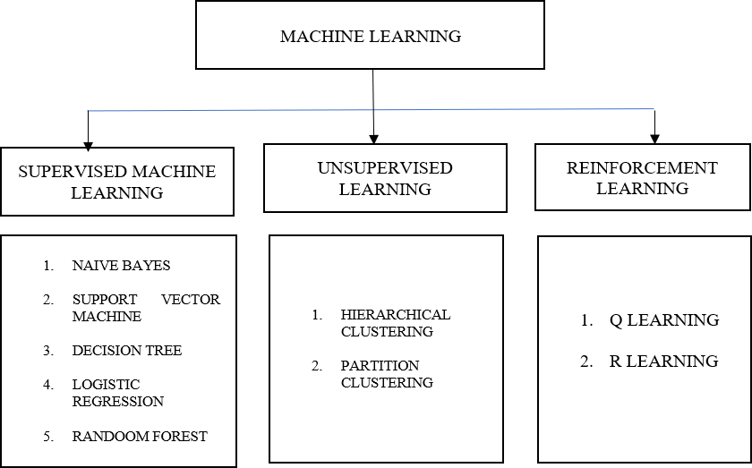

**Figure 3.1** Machine learning & types

***3.1.1 Supervised Machine Learning:***

Supervised machine learning is a learning algorithm that needs labelled data. By providing labelled data, our model is trained and predicts future events based on that trained data. In other words, we can say that supervised machine learning models analyse the existing labelled dataset and on basis of that generate a method to make predictions for upcoming future event. This type of learning is used to solve various kinds of problems like face recognition, spam classification, object classification advertisement popularity etc. Supervised machine learning has various types including:

* Naïve Bayes Classifier
* Support Vector Machine
* Random Forest
* Decision Tree
* Logistic Regression

***3.1.2 Unsupervised Machine Learning:***

Unsupervised machine learning are the algorithms in which training dataset is not labelled. Unsupervised machine learning algorithms generate solution for hidden structures inferring a feature from labelled dataset. Unsupervised learning classify data by making clusters of the data based on the features of data available. Clustering is one of the main features of unsupervised machine learning algorithms and it is of two types:

* Hierarchical Clustering
* Partition Clustering

### ***3.1.3. Reinforcement Learning:***

Reinforcement learning is a type of machine learning algorithm which works on taking rewards from the environment. It is somewhat same as supervised machine learning but it follows the process of taking suitable actions to make or get maximum reward from the environment in a given situation. The main difference between supervised learning algorithm and reinforcement learning is that supervised learning algorithm works on labelled dataset while reinforcement learning is that supervised learning with no correct labelled dataset. Here, the agent decides what step should be taken to do to perform the required task. The agent learns from its experience in its environment when no labelled dataset is given.

**3.2 ALGORITHM: -**

# ***a) Random Forest Algorithm***

Random Forest is a popular machine learning algorithm that belongs to the supervised learning technique. It can be used for both Classification and Regression problems in ML. It is based on the concept of ensemble learning which is a process of combining multiple classifiers As the name suggests, "Random Forest is a classifier that contains a number of decision trees on various subsets of the given dataset and takes the average to improve the predictive accuracy of that dataset." Instead of relying on one decision tree, the random forest takes the prediction from each tree and based on the majority votes of predictions, and it predicts the final output.

The greater number of trees in the forest leads to higher accuracy and prevents the problem of overfitting.

The below diagram explains the working of the Random Forest algorithm:

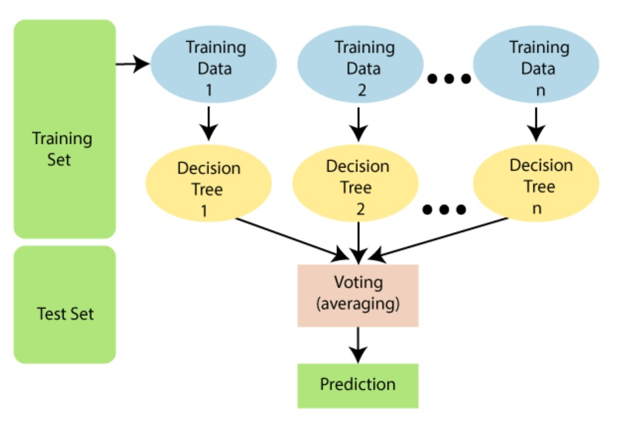

**Figure 3.2** Random Forest algorithm

Before understanding the working of the random forest, we must look into the ensemble technique. Ensemblesimplymeans combining multiple models. Thus, a collection of models is used to make predictions rather than an individual model.

***Ensemble uses two types of methods*:**

#### **Bagging-:**

Bagging, also known as ***Bootstrap Aggregation*** is the ensemble technique used by random forest.Bagging chooses a random sample from the data set. Hence each model is generated from the samples (Bootstrap Samples) provided by the Original Data with replacement known as ***row sampling***. This step of row sampling with replacement is called ***bootstrap***. Now each model is trained independently which generates results. The final output is based on majority voting after combining the results of all models. This step which involves combining all the results and generating output based on majority voting is known as ***aggregation***.

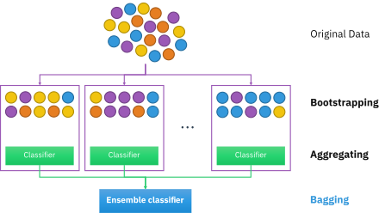

**Figure 3.3** Bagging

* ***Boosting–:***

It combines weak learners into strong learners by creating sequential models such that the final model has the highest accuracy. For example, ADA BOOST, XG BOOST.

**Steps involved in random forest algorithm:**

Step 1: In Random Forest n number of random records are taken from the data set having k number of records.

Step 2: Individual decision trees are constructed for each sample.

Step 3: Each decision tree will generate an output.

Step 4: Final output is considered based on ***Majority Voting or Averaging*** for Classification and regression respectively.

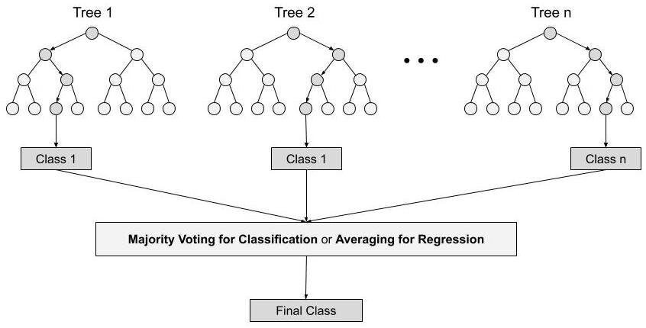**Figure 3.4** steps involved in random forest

***B) Column Transfer***

The developers of the library might have realised that people use LabelEncoding and OneHotEncoding very frequently. So, they decided to come up with a new library called the ColumnTransformer, which will basically combine LabelEncoding and OneHotEncoding into just one line of code. And the result is exactly the same.

Column Transformer is a sciket-learn class used to create and apply separate transformers for numerical and categorical data. To create transformers, we need to specify the transformer object and pass the list of transformations inside a tuple along with the column on which you want to apply the transformation.

One-hot Encoding is a type of vector representation in which *all of the elements* in a vector are 0, except for one, which has 1 as its value, where 1 represents a Boolean specifying a category of the element.

There also exists a similar implementation called *One-Cold Encoding*, where all of the elements in a vector are 1, except for one, which has 0 as its value.

For instance, [0, 0, 0, 1, 0] and [1 ,0, 0, 0, 0] could be some examples of one-hot vectors. A similar technique to this one, also used to represent data, would be [dummy variables](https://en.wikipedia.org/wiki/Dummy_variable_(statistics)) in statistics.

This is very different from other encoding schemes, which all allow multiple bits to have 1 as its value. Below is a table that compares the representation of numbers from 0 to 7 in binary, Gray code, and one-hot:

|  |  |  |  |
| --- | --- | --- | --- |
| **Decimal** | **Binary** | **Gray code** | **One-Hot** |
| 0 | 000 | 000 | 0000000 |
| 1 | 001 | 001 | 0000001 |
| 2 | 010 | 011 | 0000010 |
| 3 | 011 | 010 | 0000100 |
| 4 | 100 | 110 | 0001000 |
| 5 | 101 | 111 | 0010000 |
| 6 | 110 | 101 | 0100000 |
| 7 | 111 | 100 | 1000000 |

* 1. **TOOLS AND TECHNOLOGY USED**

**a) Flask**

Flask is a web application framework written in Python. Armin Ronacher, who leads an international group of Python enthusiasts named Pocco, develops it.

It provides libraries to build lightweight web applications in python. Flask is considered as a micro framework. Before learning Flask, you must have the basic knowledge of Python concepts.

Flask is based on Werkzeuge WSGI toolkit and Jinja2 template engine. Both are Pocco projects.

It basically allows creating web applications in a Pythonic syntax and concepts. With Flask, we can use Python libraries and tools in our web applications. Using Flask, we can set up a webserver to load up some basic HTML templates along with Jinja2 templating syntax.

**b) HTML**

The Hypertext Markup Language, or HTML is the standard markup language for documents designed to be displayed in a web browser. It can be assisted by technologies such as Cascading style sheets (CSS) and scripting languages such as JavaScript. Web browser receive HTML documents from a web server or from local storage and render the documents into multimedia web pages. HTML describes the structure of a web page semantically and originally included cues for the appearance of the document.

HTML elements are the building blocks of HTML pages. With HTML constructs, images and other objects such as interactive forms may be embedded into the rendered page. HTML provides a means to create structured documents by denoting structural semantics for text such as headings, paragraphs, lists, links, quotes and other items. HTML elements are delineated by tags, written using angle brackets. Tags such as <img /> and <input /> directly introduce content into the page. Other tags such as <p> surround and provide information about document text and may include other tags as sub-elements. Browsers do not display the HTML tags, but use them to interpret the content of the page.

HTML can embed programs written in a scripting language such as JavaScript, which affects the behavior and content of web pages. Inclusion of CSS defines the look and layout of content. The World Wide Web Consortium (W3C), former maintainer of the HTML and current maintainer of the CSS standards, has encouraged the use of CSS over explicit presentational HTML since 1997.

1. **CSS**

Cascading Style Sheets (CSS) is a style sheet language used for describing the presentation of a document written in a markup language such as HTML. CSS is a cornerstone technology of the World Wide Web, alongside HTML and JavaScript. CSS is designed to enable the separation of presentation and content, including layout, colors, and fonts. This separation can improve content accessibility, provide more flexibility and control in the specification of presentation characteristics, enable multiple web pages to share formatting by specifying the relevant CSS in a separate .css file which reduces complexity and repetition in the structural content as well as enabling the .css file to be cached to improve the page load speed between the pages that share the file and its formatting.

Separation of formatting and content also makes it possible to present the same markup page in different styles for different rendering methods, such as on-screen, in print, by voice (via speech-based browser or screen reader), and on Braille-based tactile devices. CSS also has rules for alternate formatting if the content is accessed on a mobile device. The name cascading comes from the specified priority scheme to determine which style rule applies if more than one rule matches a particular element. This cascading priority scheme is predictable.

The CSS specifications are maintained by the World Wide Web Consortium (W3C). Internet media type (MIME type) text/CSS is registered for use with CSS by RFC 2318 (March 1998). The W3C operates a free CSS validation service for CSS documents. In addition to HTML, other markup languages support the use of CSS including XHTML, plain XML, SVG, and XUL.

**d) JavaScript**

JavaScript is a text-based programming language used both on the client-side and server-side that allows you to make web pages interactive. Where HTML and CSS are languages that give structure and style to web pages, JavaScript gives web pages interactive elements that engage a user. Common examples of JavaScript that you might use every day include the search box on Amazon, a news recap video embedded on The New York Times, or refreshing your Twitter feed.

Incorporating JavaScript improves the user experience of the web page by converting it from a static page into an interactive one. To recap, JavaScript adds behaviour to web Page.

1. **Kaggle**

Kaggle is an online community platform for data scientists and machine learning enthusiasts. Kaggle allows users to collaborate with other users, find and publish datasets, use GPU integrated notebooks, and compete with other data scientists to solve data science challenges. The aim of this online platform (founded in 2010 by Anthony Goldbloom and Jeremy Howard and acquired by Google in 2017) is to help professionals and learners reach their goals in their data science journey with the powerful tools and resources it provides. As of today (2021), there are over 8 million registered users on Kaggle.

1. **PYTHON**

***f.1) Pandas***

Pandas is a Python library used for working with data sets. It has functions for analyzing, cleaning, exploring, and manipulating data. The name "Pandas" has a reference to both "Panel Data", and "Python Data Analysis" and was created by Wes McKinney in 2008.

Pandas allows us to analyze big data and make conclusions based on statistical theories. Pandas can clean messy data sets, and make them readable and relevant. Relevant data is very important in data science.

Pandas gives you answers about the data. Like:

• Is there a correlation between two or more columns?

• What is average value?

• Max value?

• Min value?

***f.2) Numpy***

NumPy is the fundamental package for scientific computing in Python. It is a Python library that provides a multidimensional array object, various derived objects (such as masked arrays and matrices), and an assortment of routines for fast operations on arrays, including mathematical, logical, shape manipulation, sorting, selecting, I/O, discrete Fourier transforms, basic linear algebra, basic statistical operations, random simulation and much more. NumPy stands for Numerical Python.

NumPy is a Python library used for working with arrays.

It also has functions for working in domain of linear algebra, Fourier transform, and matrices.

***f.3) SCIKIT-Learn***

Scikit-learn (Sklearn) is the most useful and robust library for machine learning in Python. It provides a selection of efficient tools for machine learning and statistical modeling including classification, regression, clustering and dimensionality reduction via a consistence interface in Python. This library, which is largely written in Python, is built upon **NumPy, SciPy** and **Matplotlib**.

it provides simple and efficient tools for data mining and data analysis. It features various classification, regression and clustering algorithms including support vector machines, random forests, gradient boosting, k-means, etc. it is open source, commercially usable – BSD license.

***f.4) Pickle***

Python pickle module is used for serializing and de-serializing python object structures. The process to converts any kind of python objects (list, dict, etc.) into byte streams (0s and 1s) is called pickling or serialization or flattening or marshalling. We can convert the byte stream (generated through pickling) back into python objects by a process called as unpickling.

In real world scenario, the use pickling and unpickling are widespread as they allow us to easily transfer data from one server/system to another and then store it in a file or database.

Any object in Python can be pickled so that it can be saved on disk. The idea is that this character stream contains all the information necessary to reconstruct the object in another python script.

1. **GITHUB**

GitHub is a code hosting platform for version control and collaboration. It lets you and others work together on projects from anywhere.

This tutorial teaches you GitHub essentials like repositories, branches, commits, and pull requests. You'll create your own Hello World repository and learn GitHub's pull request workflow, a popular way to create and review code.

* Create and use a repository
* Start and manage a new branch
* Make changes to a file and push them to GitHub as commits
* Open and merge a pull request

1. **GOOGLECOLAB**

Collaboratory, or “Collab” for short, is a product from Google Research. Collab allows anybody to write and execute arbitrary python code through the browser, and is especially well suited to machine learning, data analysis and education. More technically, Collab is a hosted Jupyter notebook service that requires no setup to use, while providing access free of charge to computing resources including GPUs.

1. **WEATHER API**

A weather API is an Application Programming Interface that allows weather data to be queried from scripts and code. Good weather APIs provide both historical weather data and forecast data via an easy-to-use, well-defined programming interface. The best APIs have dozens of weather measures, near-real-time current conditions reporting, and decades of worldwide historical weather reports. Ideally both historical and forecast look-ups would be combined into the same API entry point with the addition of an ultra-long-range forecast based on climate statistics.

A weather API is ideally suited for use cases that need large volumes of weather data or need to access weather data in an automated way.

**j) RENDER**

Render template is a Flask function from the flask. templating package. render template is used to generate output from a template file based on the Jinja2 engine that is found in the application's templates folder. Note that render template is typically imported directly from the flask package instead of from flask.

A template is rendered with specific data to produce a final document. Flask uses the Jinja template library to render templates. In your application, you will use templates to render HTML which will display in the user's browser. In Flask, Jinja is configured to auto escape any data that is rendered in HTML templates.

**3.4 SOFTWARE RQUIREMENT**

* PYTHON 3.10 version
* GoogleColab
* VS-Code
* SCI-KET learn, PANDA, NUMPY

**3.5 HARDWARE REQUIREMENT**

* Processor Pentium IV and motherboard
* RAM 256 mb or above
* HARD DISK 4GB or above
* Printers for reports
* Keyboard, mouse
* Monitor, CPU

**CHAPTER-4**

**ANALYSES OF DATASET**

**4.1 DATASETS USED FOR CROP PREDICTION-:**

Precision agriculture is in trend nowadays. It helps the farmers to get informed decision about the farming strategy. Here, I present you a dataset which would allow the users to build a predictive model to recommend the most suitable crops to grow in a particular farm based on various parameters.

### Data fields

* N - ratio of Nitrogen content in soil
* P - ratio of Phosphorous content in soil
* K - ratio of Potassium content in soil
* temperature - temperature in degree Celsius
* humidity - relative humidity in %
* ph. - ph. value of the soil
* rainfall - rainfall in mm

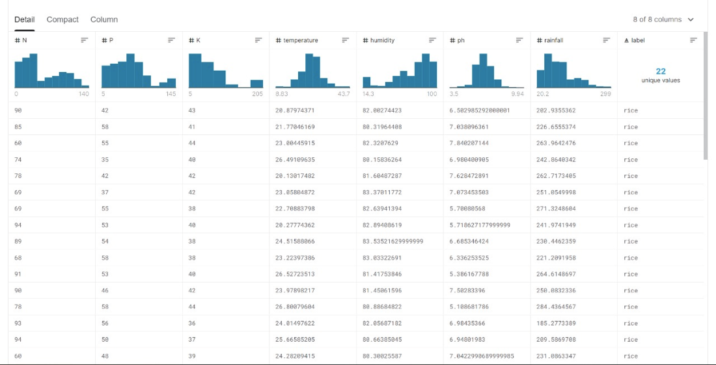

**Figure 4.1** dataset for crop prediction 1

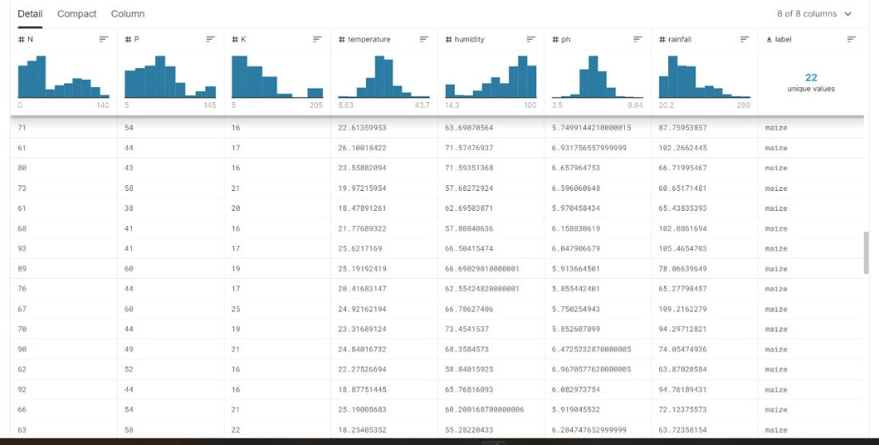

**Figure 4.2** dataset for crop prediction 2

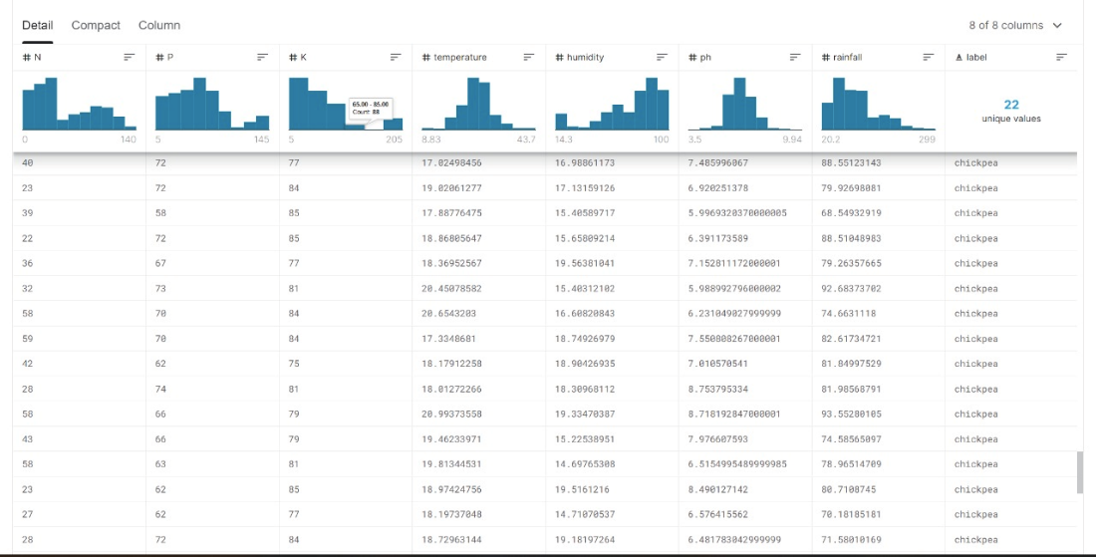

**Figure 4.3** dataset for crop prediction 3

**4.2 DATASET USED FOR FERTILISER PREDICTION-:**

Here is the data of various fertilizers information. This data was by researching various websites and sources. You can use this data for further prediction and analysis.

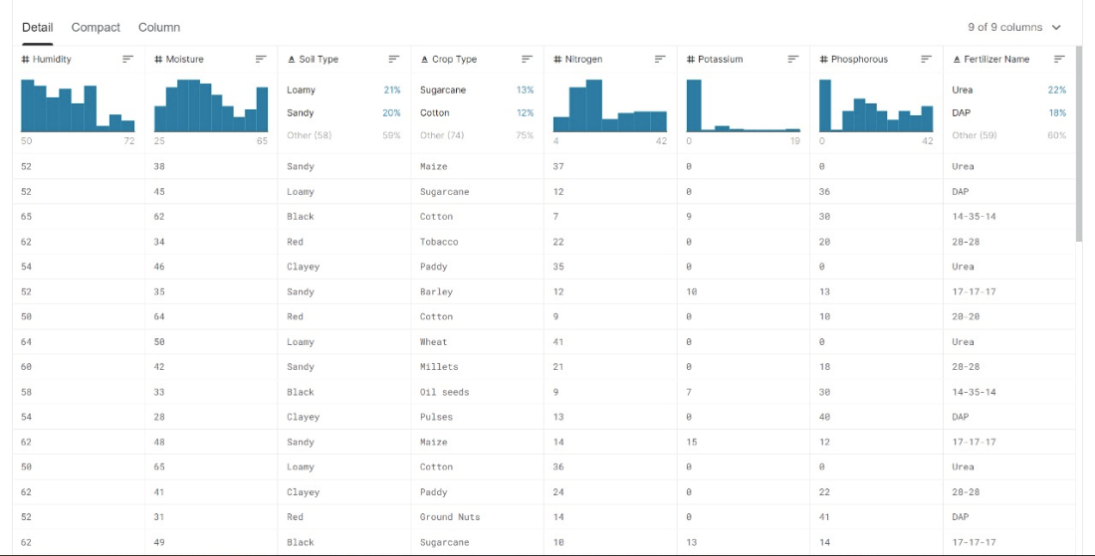

**Figure 4.4** dataset for fertilizer prediction 1

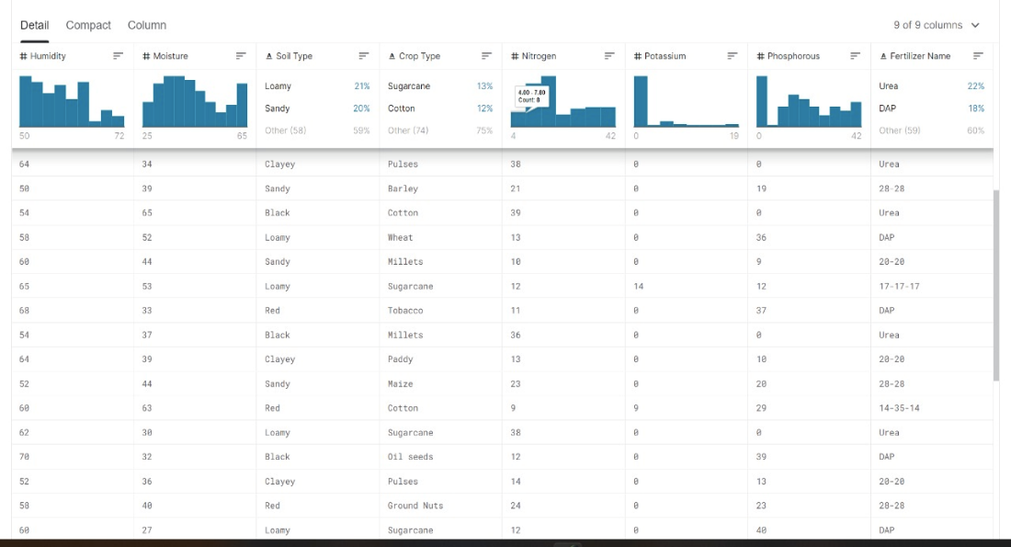

**Figure 4.5** Dataset For Fertiliser Prediction 2

**4.3 MEASURING ACCURACY -**

To get the maximum accuracy of this model to analyse the datasets, we performed different listed model and check the accuracy, after that which model generate the maximum accuracy we implement in this model -

1. Using decision tree
2. Using gaussian naïve model
3. Using support vector machine
4. Using logistic regression
5. Using random forest algorithm
6. ***Accuracy measured by decision tree***

Decision tree measured the accuracy of the model using the functions- Entropy, Random_state and maximum depth. The accuracy provided by the decision tree model is 0.9.

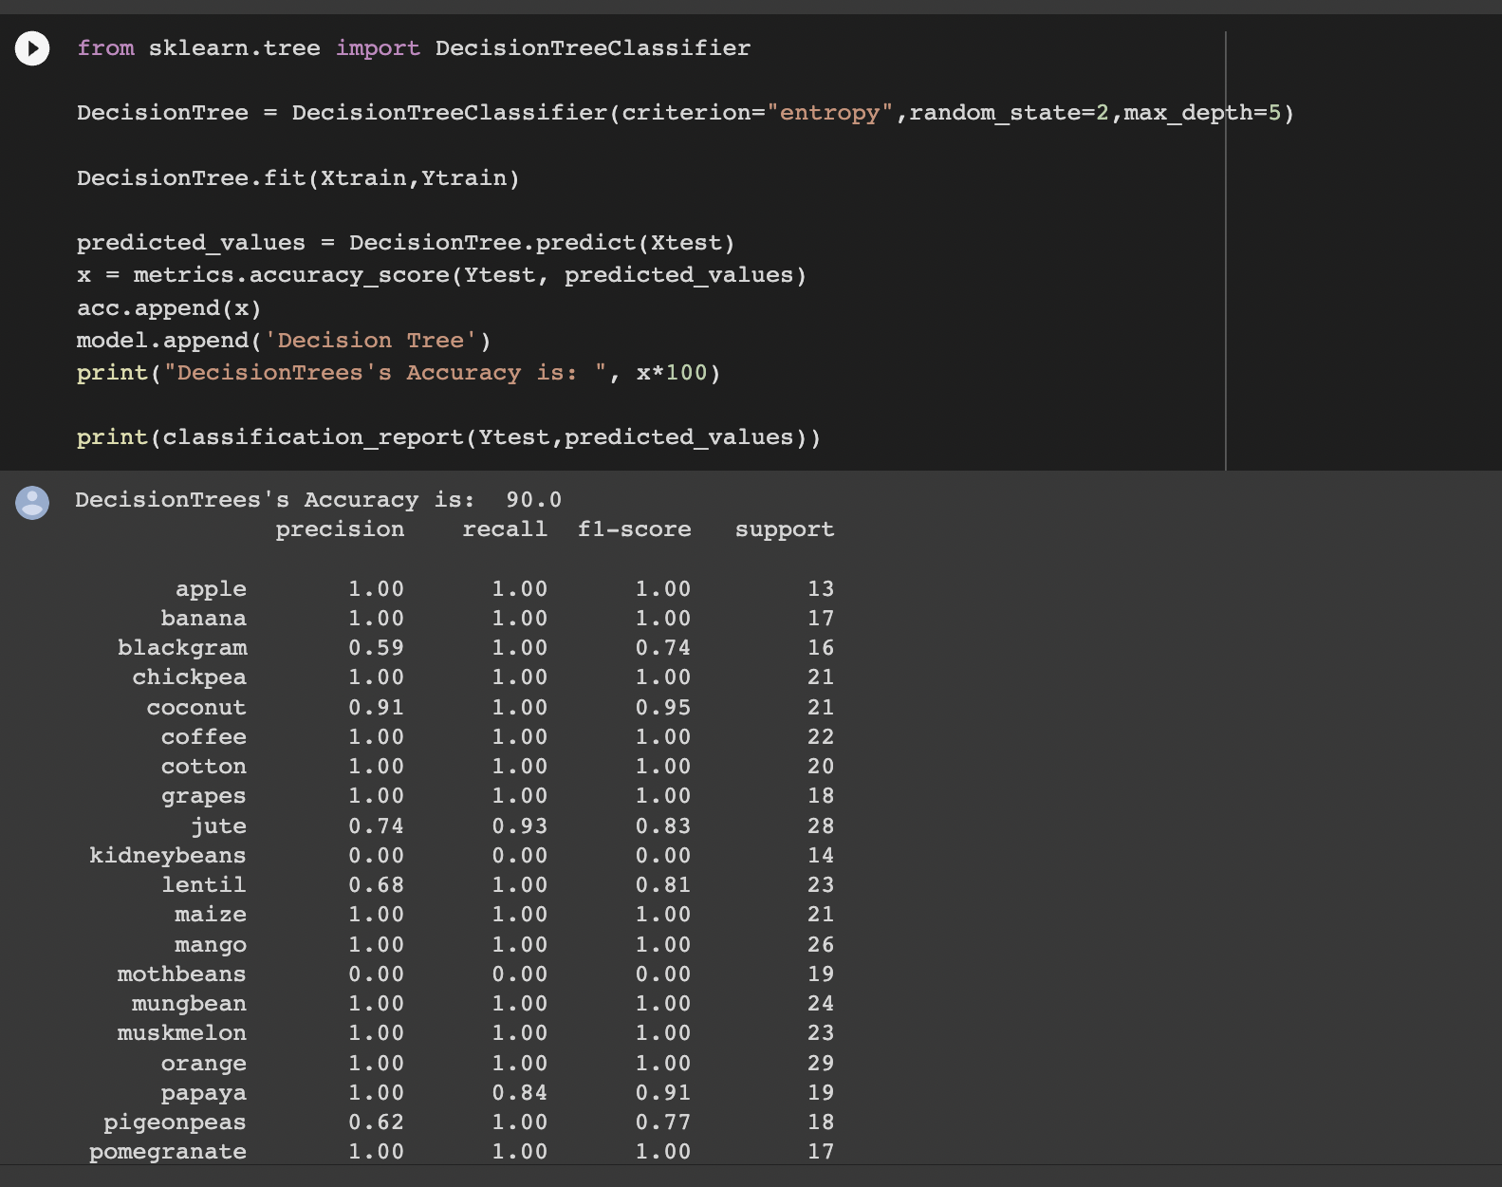

**Figure 4.6** Decision Tree Accuracy

1. ***Accuracy measured by gaussian naïve model***

This algorithm used two factors to measure the accuracy of the model- xtrain(input of training data) and ytrain(output of training data). After performing output of testing dataset, it measured the accuracy of the model which is 0.99090090091.

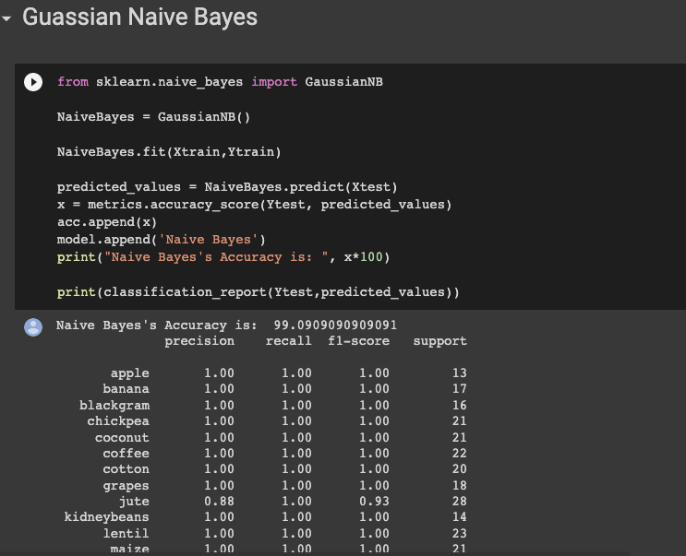

**Figure 4.7** Gaussian Naïve Accuracy

1. ***Accuracy measured by Support Vector Machine***

As gaussian naïve model this algorithm also uses two factors to measure the accuracy of the model- xtrain(input of training data) and ytrain(output of training data). It performs tests on input of testing data and output of testing data to measure the accuracy which is 0.1068181818.

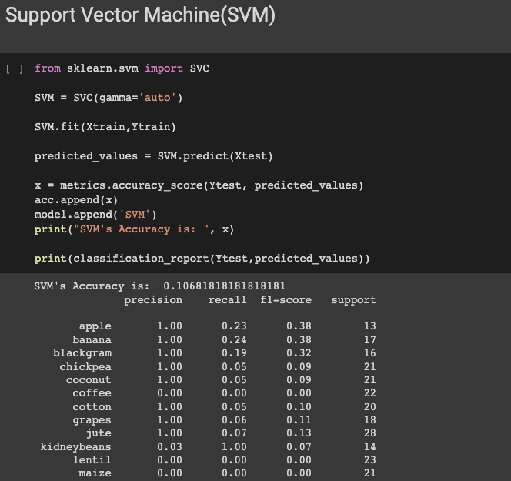

**Figure 4.8** Support Vector Machine Accuracy

1. ***Accuracy measured by logistic regression***

Logistic regression uses a function called random_state which performs a ytest on xtrain and ytrain. It provides an accuracy of 0.952272727272.

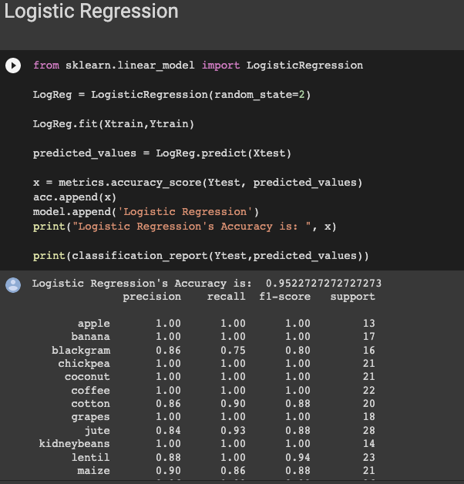

**Figure 4.9** Logistic Regression Accuracy

1. ***Accuracy Measured By Random Forest Model***

Random forest uses two factors- n_estimator and random_state to perform ytest on xtrain and ytrain. It provides an accuracy of 0.99090909090901.

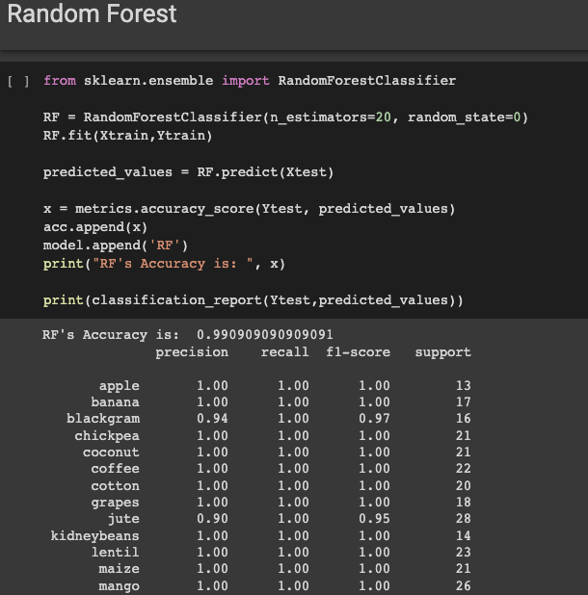

**Figure 4.10** Random Forest accuracy

**CHAPTER-5**

**IMPLEMENTATION/RESULT**

**5.1 FLOW CHART**

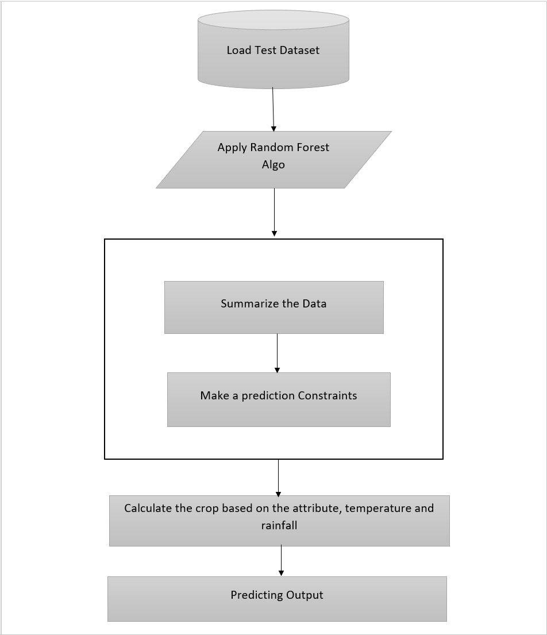

**Figure 5.1** flow chart



**Figure 5.2** flow chart 2

**5.2 SCREENSHOTS:**

***5.2.1 Services/Home screen-:***

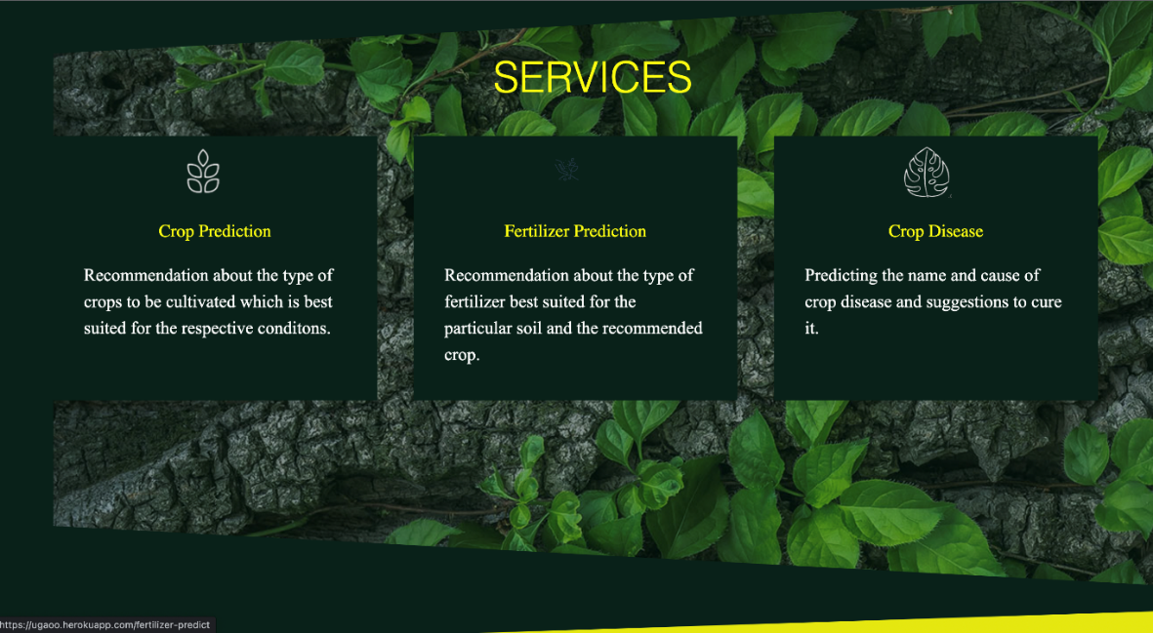

**Figure 5.3** Home screen

***5.2.2 Crop Prediction-:***

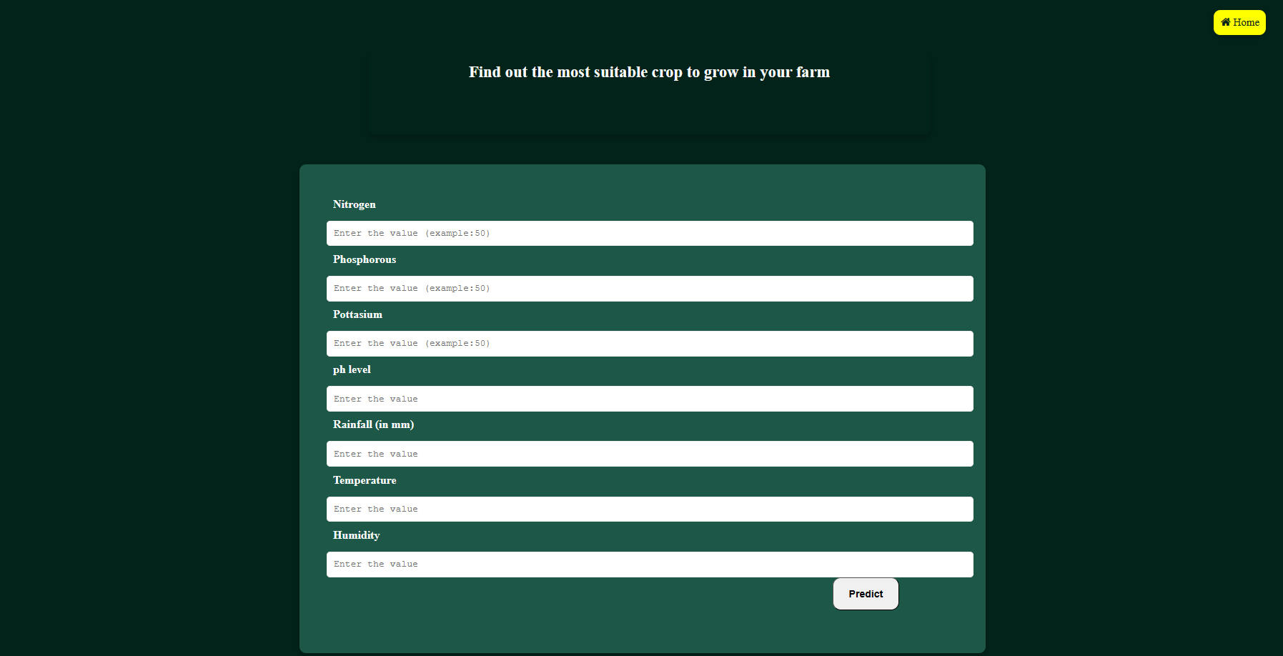**Figure 5.4** crop prediction

***5.2.3 Input For Crop Prediction-:***

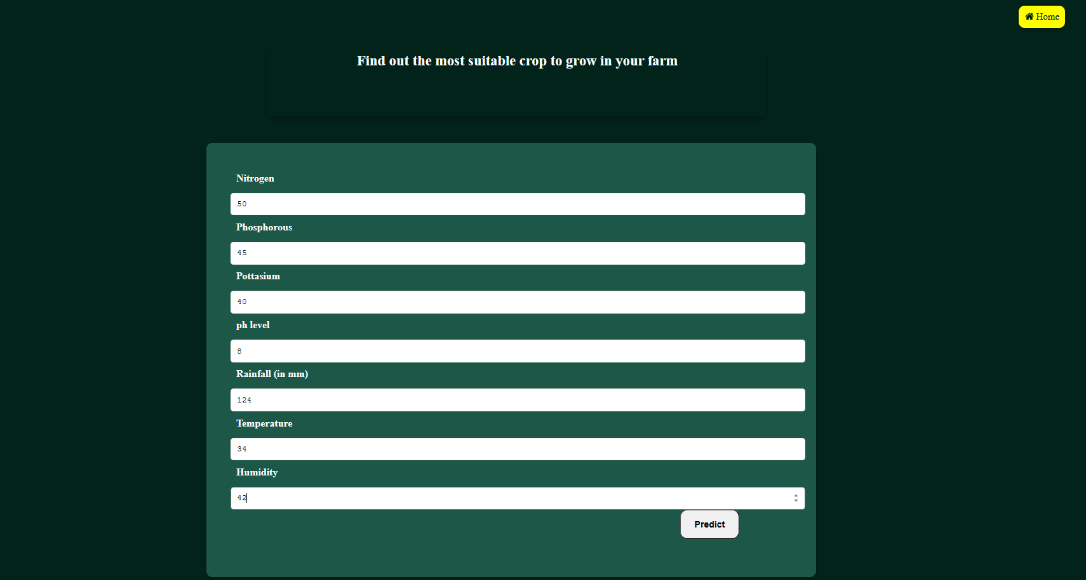**Figure 5.5** Input for crop prediction

***5.2.4 Crop Prdiction Output-:***

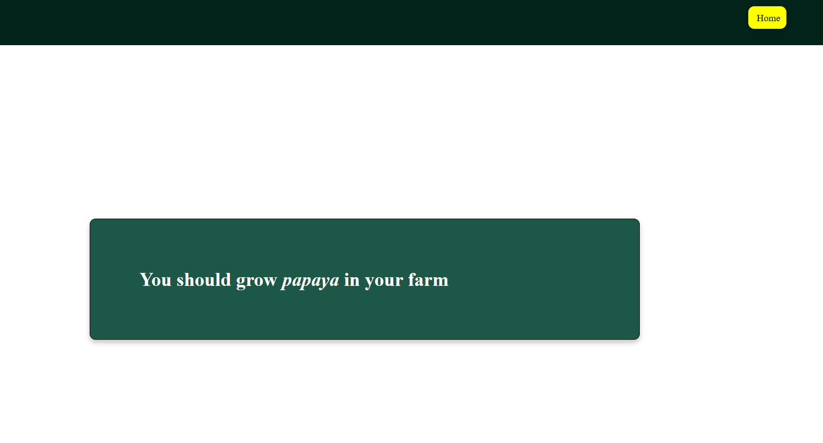**Figure 5.6** Crop prediction output

***5.2.5 Fertiliser Prediction-:***

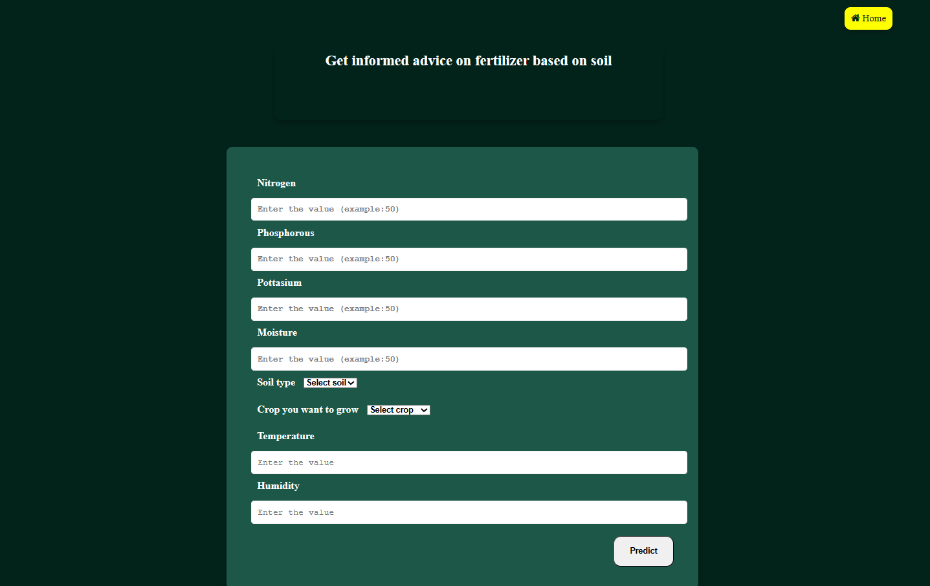**Figure 5.7** fertiliser prediction

***5.2.6 Input For Fertiliser Prediction-:***

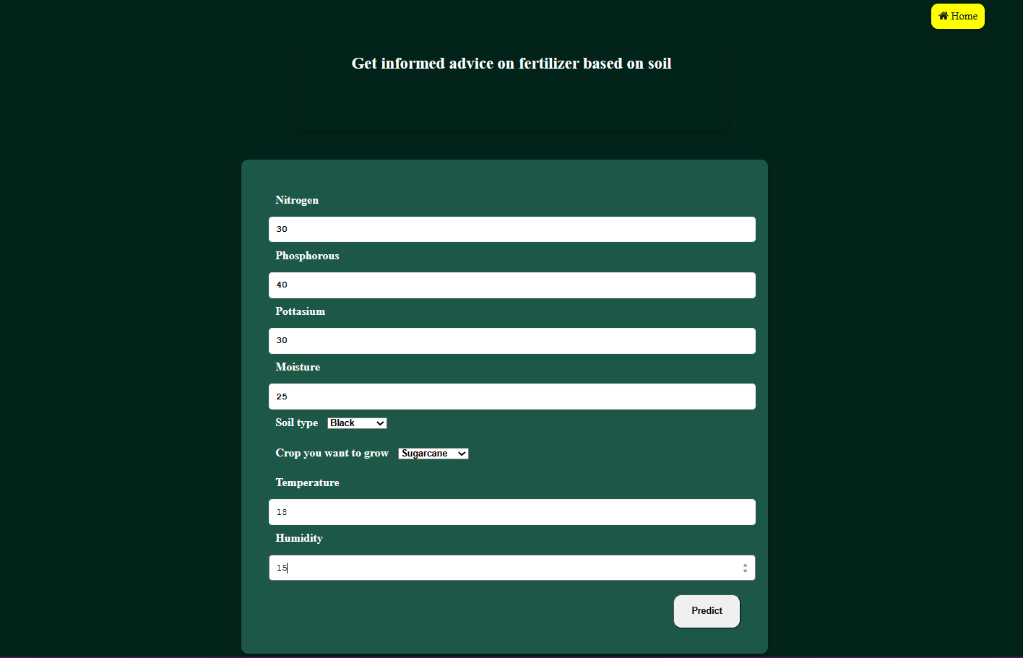**Figure 5.8** Input for fertiliser prediction

***5.2.7 Fertiliser Prediction Output-:***

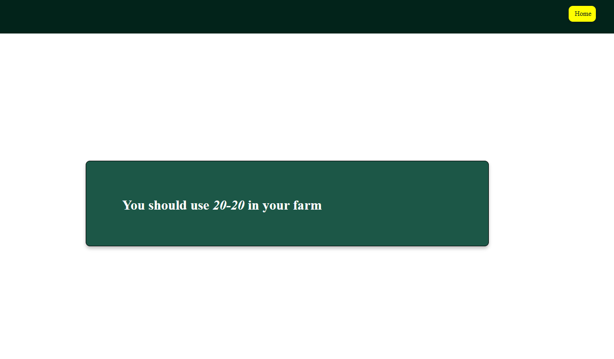

**Figure 5.9** Fertiliser prediction output

**CHAPTER 6**

**CONCLUSION**

Based on the climatic input parameters the present study provided the demonstration of the potential use of data mining techniques in predicting the crop yield based. The developed webpage is user friendly and the accuracy of predictions are above 75 per cent in all the crops and districts selected in the study indicating higher accuracy of prediction. By providing climatic data of that place the user-friendly web page developed for predicting crop yield can be used by any user their choice of crop.

Weather aberrations can cause physical damage to crops. With help of this project, we can predict in certain environmental conduction which crop should be taken. From the graph of % of production we can determine sowing and harvesting period of particular crop in given temperature and rainfall. This data will continue to enhance farmer efficiency by further enabling them to monitor each plot of land and determine the precise input needed for their crops.

**6.1 FUTURE SCOPE:**

As our project progresses, we are committed to continually adapting to new challenges and opportunities, with the ultimate goal of achieving long-term success and sustainability. We have mainly two future scopes of our project:

***6.1.1 Language Translator-:***

Language barrier is the most common problem in our country. Indian farmers are not very well educated so they face a common problem of language as most of the platforms use English as a general language. In the future we are going to provide a language translator in our model which will provide both options for English as well as Hindi language so that language barrier is no longer a problem for our farmers and they can use our services by themselves without any outer help.

***6.1.2 Disease Prediction-:***

Crop diseases are a major threat to food security, but their rapid identification remains difficult in many parts of the world due to the lack of the necessary infrastructure. The combination of increasing global smartphone penetration and recent advances in computer vision made possible by deep learning has paved the way for smartphone-assisted disease diagnosis. Using a public dataset of sample images of diseased and healthy plant leaves collected under controlled conditions, we will train a deep convolutional neural network to identify several crop species and every possible disease. The trained model will achieve a well predicted outcome on a held-out test set, demonstrating the feasibility of this approach. Overall, the approach of training deep learning models on increasingly large and publicly available image datasets presents a clear path toward smartphone-assisted crop disease diagnosis on a massive global scale.

**REFERENCES**

1. S. Veenadhari, Bharat Misra and CD Singh, "Machine learning approach for forecasting crop yield based on climatic parameters", International Conference on Computer Communication and Informatics (ICCCI), 2019, 2014.
2. S. Das. Filters, wrappers and a boosting-based hybrid for feature selection. In International conference on machine learning 1 (2001), pp. 74–81.
3. .F. Balducci, D. Impedovo, and G. Pirlo, Machine learning applications on agricultural datasets for smart farm enhancement, Machines 6 (2018), pp. 38–59. doi:https://doi.org/10.3390/machines6030038. [Crossref], [Web of Science ®], [Google Scholar].
4. Girish L, Gangadhar S, Bharath T R, Balaji K S, Abhishek K T “Crop Yield and Rainfall Prediction in Tumakuru District using Machine Learning.
5. P. Priya, U. Muthaiah and M. Balamurugan, "Predicting yield of the crop using machine learning algorithm", International Journal of Engineering Science Research Technology (IJESRT), 2018.
6. GoogleColab- used to check the accuracy of the model. We checked 4 algorithms and we implemented the most accurate one.
7. JavaTpoint – we studied the working strategies and implementing process of Random Forest algorithm on javatpoint.
8. CROPPROPHET -www.cropprophet.com
9. HARVESTIFY - harvestify.herokuapp.com
10. Frontliners article (for plant disease prediction)- www.frontiersin.org/articles/10.3389/fpls.2016.01419/full
11. W. Edwards, P. Duffy, in Encyclopedia of Agriculture and Food Systems, 2014 - www.sciencedirect.com/topics/earth-and-planetary-sciences/agricultural-production
12. Kaggle ( https://www.kaggle.com ) - It is used for crop recommendation and fertilizers recommendations.

* For crop recommendation CV file - '/content/Crop_recommendation.csv'
* For fertilizer recommendation CV file - "/content/Fertilizer Prediction.csv"